BRONCHUS 2021
PROGRAMME AGENDA

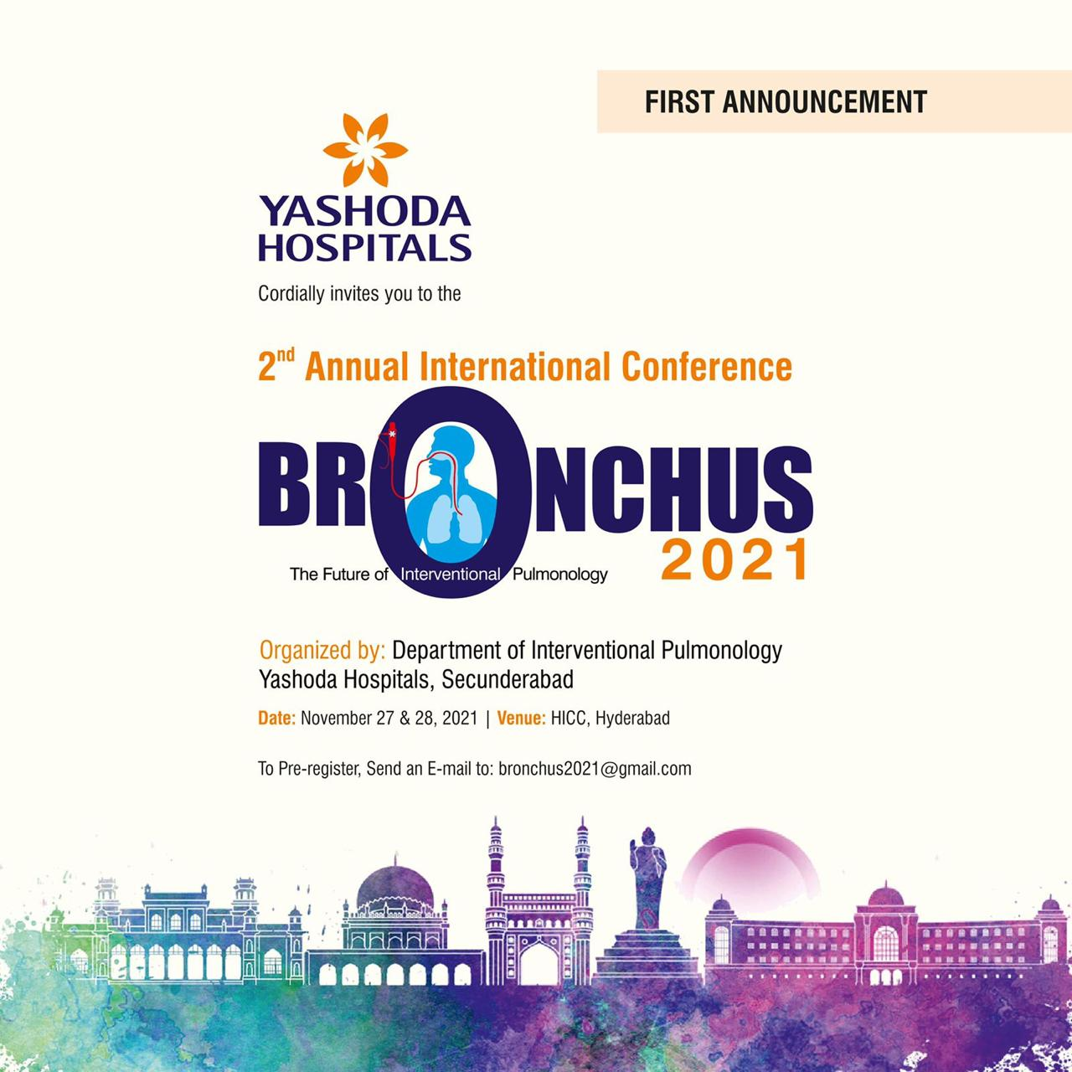

Dear Colleagues

On Behalf of the organizing committee, it is our pleasure to welcome you to the 2nd Annual International conference on Interventional Pulmonology - “BRONCHUS 2021” and to the city of pearls - Hyderabad on November 27-28, 2021.

The Theme of the congress is “Return to work – The path ahead”

As the field of Interventional pulmonology continues to expand and develop at a rapid pace, this 2-day conference will focus on best practices in Interventional Pulmonology from basics to the most advanced diagnostics and therapeutics. Experts across the globe will discuss on disease specific interventions with case-based approach to learning. Highlights of the conference would be the focused training programme [FTP] on procedural techniques. The first day of the congress is exclusively tailored to impart procedural skills to upcoming Interventional Pulmonologists through the FTP sessions. On the second day experts will discuss the latest evidence-based approaches through didactic sessions.

We are proud to bring you a great synergy of expertise from internationally renowned scientists and pioneers in Interventional Pulmonology through BRONCHUS 2021. The scientific program is targeted to provide tangible benefits and networking opportunities to current pulmonologists; it also provides a tremendous environment for early career members to learn about future prospects and professional development activities.

BRONCHUS 2021 is mentored by a host of distinguished National and International faculty with decades of experience in Interventional Pulmonology.

In addition to the outstanding scientific program, we hope that you will find time to explore the City of Pearls - Hyderabad

Welcome to the “City of pearls”, Hyderabad and experience BRONCHUS 2021.

We Look forward to seeing you

Dr. Pavan Gorukanti M.D, ABIM Dr. Hari Kishan Gonuguntla M.D, D.M
Managing Director, Yashoda Hospitals Congress President – BRONCHUS 2021

Day 1 programme :

LEARNING FROM EXPERTS
PROCEDURAL TRAINING ON MODELS & VET LABS
Live Cases in the Operating Rooms
Industry Sponsored Symposium
FTP will focus on comprehensive procedural techniques and training
Fellowship networking opportunities and fellowship applications will be accepted

BRONCHUS 2021 will continue to adapt procedural training format of focused training programs, where expert faculty will help the participant’s gain knowledge to individual procedures in a focused environment.
Each FTP will be led by expert International and National faculty in the specified procedure.
Attendees will learn about these developments and how to put them in to practice and it will have relevance for trainees, fellows, and consultant specialists. This gives opportunity for the early career members to discuss fellowship opportunities with the international faculties.

Participants can choose to attend focused training programs at the time of registration.
For the first time, BRONCHUS 2021 gives platform to explore single use bronchoscopes, disposable cryoprobes, under the guidance of international experts.

DAY 1: FOCUSSED TRAINING PROGRAMMES [FTP]

TIME – 10:00 AM -18:00 PM
FTP 1 – PAEDIATRIC BRONCHOSCOPY
Endorsed by APIPA – Asian Paediatric Interventional Pulmonology Association
(5 Lectures + 5 stations) limited to 30 participants

TIME – 10:00 AM -18:00 PM
FTP 2 – RIGID BRONCHOSCOPY & Airway Stenting
(5 Lectures + 4 stations) limited to 30 participants

TIME – 10:00 AM -18:00 PM
FTP 3 – CRYO and Electrosurgery
(5 Lectures + 4 stations) limited to 30 participants

TIME – 10:00 AM -18:00 PM
FTP 4 – BRONCHIAL THERMOPLASTY
(5 Lectures + 2 stations) limited to 30 participants

TIME – 10:00 AM -18:00 PM
FTP 5 –Navigation Bronchoscopy
(5 Lectures + 2 stations) limited to 15 participants

TIME – 10:00 AM -18:00 PM
FTP 6 – Basic Bronchoscopy for Beginners
(5 Lectures + 7 stations) limited to 50 participants

TIME – 10:00 AM -18:00 PM
FTP 7 – Convex EBUS and Radial Probe EBUS
(6 Lectures + 6 stations) limited to 40 participants

TIME – 10:00 AM -18:00 PM
FTP 8 – Bronchoscopy & Ultrasound in the ICU
(5 Lectures + 4 stations) limited to 30 participants

TIME – 10:00 AM -18:00 PM
FTP 9 – Medical Thoracoscopy & Pleural Procedures
(5 Lectures + 4 stations) limited to 40 participants

TIME – 10:00 AM -18:00 PM
FTP 10 – Bronchoscopy for the Nurses
(5 Lectures + 4 stations) limited to 20 participants

End of Day 1 training followed by Dinner and Cocktail……………..

TIME – 19:00 PM -23:00 PM – GALA DINNER + Global IP Contest
BEST VIDEO and IMAGE PRESENTATION WITH PRIZES

Note: Video Submission Guidelines – Kindly refer to the website/ Challenging & innovative cases in IP are accepted for presentation with a time limit of 5 minutes for presentation and discussion.

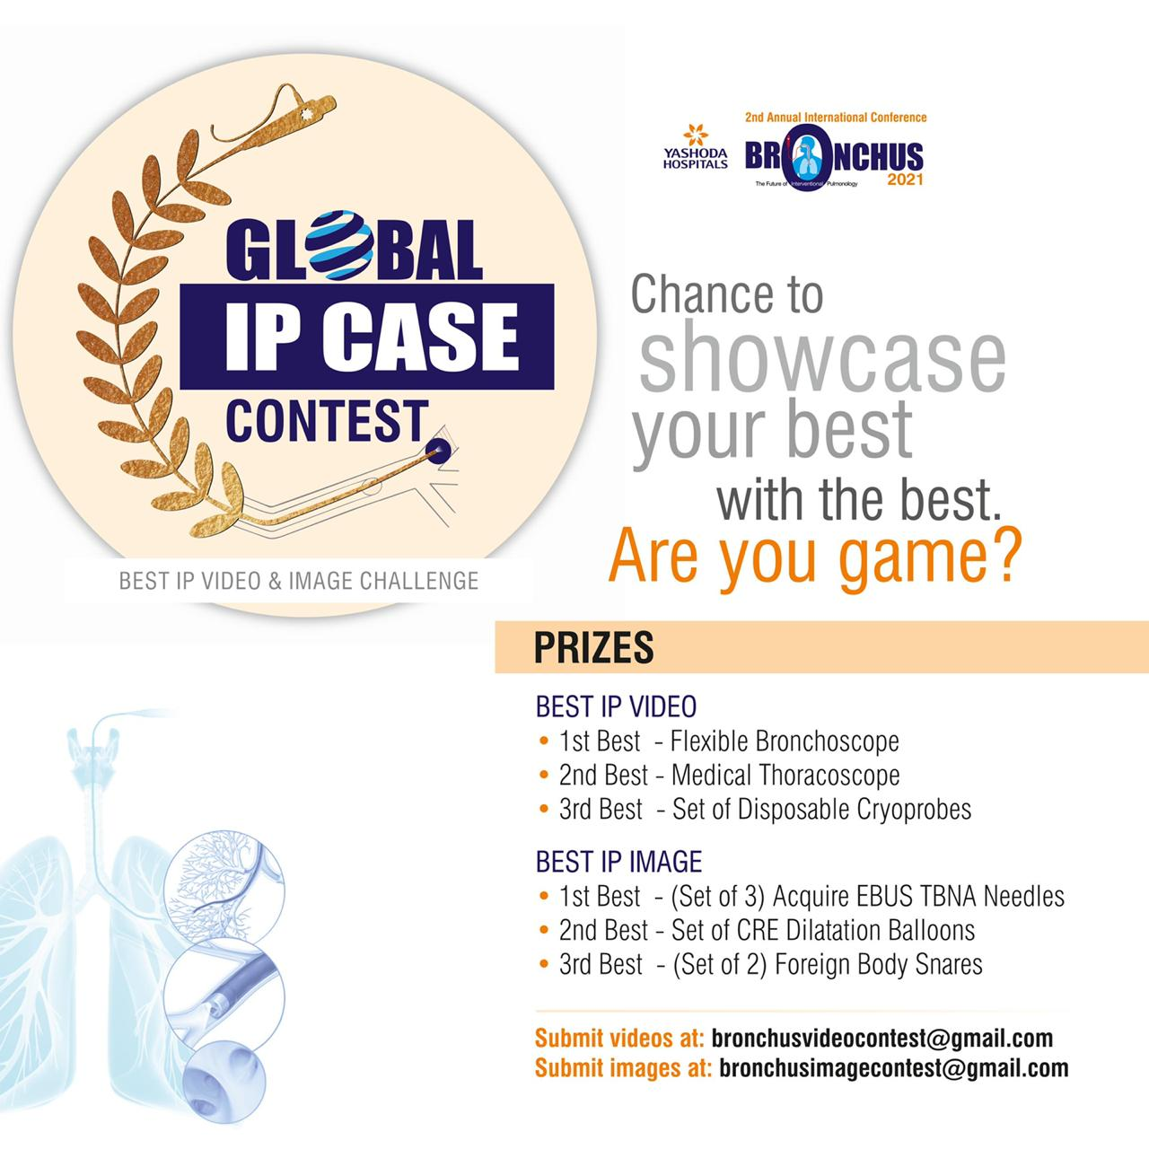

Day 2 Programme :
08:00 - 09:00 Registration Badges and Continental Breakfast
09:00 - 09:15 | Welcome Address
Session : COVID -19 and Bronchoscopy
09:15 - 09:30 | The Pandemic Challenges to Bronchoscopy - overcoming challenges
09:30 - 09:45 | COVID-19 and Bronchoscopy - Experience, Utility and Evidence
09:45 - 10:00 | The Journey to single use bronchoscopes – Changing Practice
Session : Endobronchial Ultrasound (Linear Probe)
10:00 - 10:15 | Comparison of EBUS Needle sizes & shapes : Tissue adequacy and Diagnostic yield - Core or no Core - Does it really Matter?
10:15 - 10:30 | EBUS Specimens in the Era of NGS panel : Improving the Yield of EBUS Specimens - Tips & Tricks
10:30 - 10:45 | Year in review - EBUS TBNA
10:45 - 11:00 | EBUS Transbronchial Cryo-nodal Biopsies (EBUS - TBCNB)
Inauguration Ceremony
Session : Bronchoscopy for PPN - will the Robots surpass the Ninjas ?
11:00 - 11:30 | Radial EBUS & PPN – (No PRO/CON) – The Robots still need it
11:30 - 11:45 | Cone Beam CT
11:45 - 12:00 | Navigation Platforms and BTPNA
12:00 - 12:15 | Body Vision Platform
12:15 - 12:45 | ROBOTICS(R) - Introduction to R Bronchoscopy & Body of Evidence
12:45 - 13:00 | Year in review - Peripheral Pulmonary Nodules
13:00 - 13:15 | Bronchoscopic Ablation for Lung Nodules – 2021 status update
Working Lunch
Session : Bronchoscopy for the Obstructive Airway Diseases ( Asthma & COPD )
13:15 - 13:30 | Bronchial Thermoplasty in 2021 - feasible for the Low FEV1 groups
13:30 - 13:45 | Bronchoscopy for the Pink Puffers – Valves/Coils/ Vapour
13:45- 14:00 | Bronchoscopy for the Blue Bloaters – Bronchial Rheoplasty
Session : Airway Obstruction (Malignant & Non Malignant Airway Obstruction)
14:00 - 14:15 | Malignant & Non - Malignant CAO - Overview
14:15 - 14:30 | Airway Stents - Choosing the right stent – Indian Perspective
14:30 - 14:45 | Distal Airway Stenting - Is it worth the effort
14:45 - 15:00 | Complications of Airway Stents - Rescue strategies
15:00 - 15:15 | Tailored Airway Stents
15:15 - 15:30 | EDAC/TBM - Stent or Operate or Positive Pressure ?
15:30 - 15:45 | Benign Airway Stenosis - Aetiology to Management
Session : Lung Transplantation : Airway Complications post Lung Transplantation
15:45 - 16:00 | Growing New Airways – what is normal & abnormal - Timeline for Bronchoscopy
16:00 - 16:15 | Airway Complications from the IP perspective
16:15 - 16: 30 | Airway Complications from the Surgeons perspective
Session : Cryobiopsies – Moving from periphery to the central (CTBLB CPPN CTBCNB)
16:30 - 16:45 | Transbronchial Cryolung Biopsy for ILD - The new normal
16:45 - 17:00 | Transbronchial Biopsy for ILD - Not the END - just a part of MDD
17:00 - 17:15 | Cryotechniques for peripheral Nodules
17:15 - 17:30 | Spray Cryotherapy
Symposium | Bronchoscopy Challenges in the Peripheral India – Overcoming challenges and industry support – Cross talk with experts from periphery and Industry partners on support and initiatives to improve bronchoscopy reach
Session : Bronchopleural Fistula
17:30 - 17:45 | The Endobronchial approach - The Bronchoscopists view
17:45 - 18:00 | The Pleural approach – The Surgeons view
Session - Medical Thoracoscopy
18:00 - 18:15 | New Scopes for the Pleural Inspection
18:15 - 18:30 | Year In review – Pleural Interventions
Session – Bronchoscopy in SPORADIC Conditions
18:30 - 18:45 | Airway Bleeding – Bronchoscopic Management
18:45 - 19:00 | Lungs in the Washing Machine – Pulmonary Alveolar Proteinosis - Technique , Tips and Experience
19:00 - 19:15 | Before we go to BED - DISE and Bronchoscopic Evaluation of Upper airway for OSA
Session - Vote of Thanks

